APRIL 2023 MARKETING PLAN

April is the month where spring really takes root. Check out a few ideas below on how you can carry out this theme all month long.

getting started
- Review ideas and pick the ones you would like to do!
- Purchase the supplies needed for your events.
- Spread the word via graphics included for each event. You can find them in the galleries on each month’s page on the website.
- During each event *with permission* take photos and make sure to post to your social media to encourage future participation and remind attending residents of all the fun they had!
Keep in mind that the materials below are customizable to your property as far as time, date, and location. Simply reach out to the marketing department and specify which piece of collateral you want adjusted and send us your changes.

CEREAL BAR rent breakfast

Invite your residents to the office for a rent breakfast to kick off the month. Get a variety of cereal options and milk and milk alternatives for those that can’t have dairy. You will need bowls/napkins/and plastic spoons for serving. Don’t forget about small drink cups and juice to go with it.
- Invite your residents via flyer, social media, textbox with the graphics included.
- On the day of your event, send out a reminder via textbox and social media.

EGGCELLENT SPRING FUN
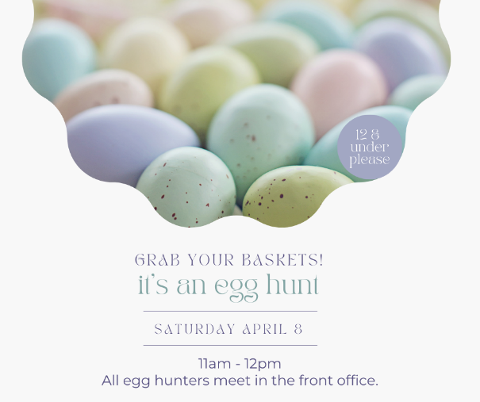
Property Egg Hunt – Hide eggs around the community and allow kids 12 and under to hunt them! They can be filled with candy, stickers, or little trinkets!
Post/hand out your flyers for the event early to give residents plenty of time to plan on participating.

WHAT YOU NEED:
- Eggs: Amazon.com: Prextex Easter Eggs Assortment 288 ct. - Best Value 288 Easter Eggs in Designed Box : Toys & Games
- Stickers: Amazon.com: 3 Pack Kids Sticker in 30 Designs,600 Pcs 1-1/2 Inch Self Adhesive Label Roll Stickers for Kids and Teacher : Toys & Games
- Candy: Candy Treats (3 pounds) of Individually Wrapped Candy: Skittles, Starburst, Swedish Fish, Twizzlers, Haibo, Airheads, Jolly Rancher, Sour Punch, Sour Patch Kids - Walmart.com

THE DAY OF THE EVENT:
- Send out a reminder and let the fun begin!

PICK AN EGG WITH A SPECIAL IN IT FOR PROSPECTS
Keep a cute basket in the office full of eggs. Fill the eggs with prizes for incoming prospects to choose from. If you can offer concessions – maybe this is a fun way to do so. If your community stays clear of offering concessions, maybe you get creative and eggs have things like - A full size candy bar on us, A soda on us, A cookie on us, etc. and you can offer them their prize before they leave. Discuss with your regional and make sure they are on board with what you hope to carry out.
See above for Eggs pricing.

SPRING TEA PARTY
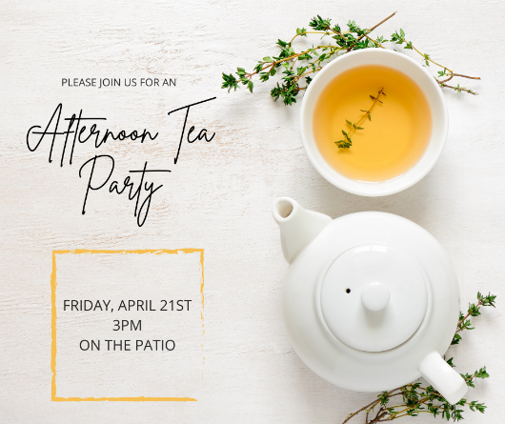
Host a spring tea party for your residents. It’s always nice to catch up and socialize over a cup of tea. You could serve warm tea options as well as cold tea options. Have a few snack options laying around. This is a great event to host inside with light music and natural light coming in or can easily be done outside on a patio or pool deck depending on your preference.

what you will need:
Disposable Tea Cups: https://www.amazon.com/Disposable-Espresso-Cups-Comfort-Handles/dp/B099X9Z5ZT/ref=sr_1_6?crid=1MN924BQMDPHM&keywords=disposable+tea+cups&qid=1646411238&sprefix=disposable+teacups%2Caps%2C65&sr=8-6
Carafe’ – The same metal carafe’s you use for cold items can be used to keep things warm. You could always steep them ahead of time and serve lukewarm.
Tea Options – Have a variety – Try to get at least one or two caffeine free options
Snack Items – Veggie Tray, Fruit Tray, Cookies, Muffins, etc.

THE DAY OF THE EVENT:
- Send out a reminder, set up your event, and enjoy!

EARTH DAY

Host a contest asking residents to submit via FB what they will be doing to help the environment in honor of Earth Day. he most liked idea wins a prize.

Raffle off reusable water bottles, grocery totes, bird feeders and other Earth Friendly items or offer these as prizes.

Throughout the week make posts with tips like:
- Don’t forget we offer paperless e-payments, always be on time and save the environment at the same time!
- Give Directions to your local recycling place
- Post a reusable hack

BEFORE THE EVENT:
- Send out flyer/social square/text box well in advance so your residents can plan on participating.
- Purchase your prizes if you are doing the raffle.

THE DAY OF THE EVENT:
- Post the social media square announcing today is the day!

world art day event
Host a Virtual Art Gallery & Art Contest! In advance, let your residents know via flyer & social that you will be hosting this event. Once submissions open-up send a reminder out. Collect submissions and then post in a gallery post on your Facebook. Announce when voting opens and encourage your residents to check it out. Establish a plan for how votes are taken (maybe it’s by likes on each piece?). Once you have a winner(s), make that announcement as well as what your winners won! Maybe part of the prize is that their artwork is displayed in the office.
If you are looking for something more social, during the week host an art gallery night where you display the actual works of art and invite people to come look. You could have simple appetizers like veggie tray/fruit tray/meat & cheese tray along with sparkling water.

BEFORE THE EVENT:
- Send out Flyer/Social Square/ Text Box information
- Get prizes for your winner(s).

THE DAY OF THE EVENT(s):
- Announce your upcoming event a few weeks early so residents can prepare.
- Make a post announcing you are accepting entries.
- Make a post a with your virtual gallery and instructions for voting.
- Make sure to announce winners via social media and have them come get their prize from the office.

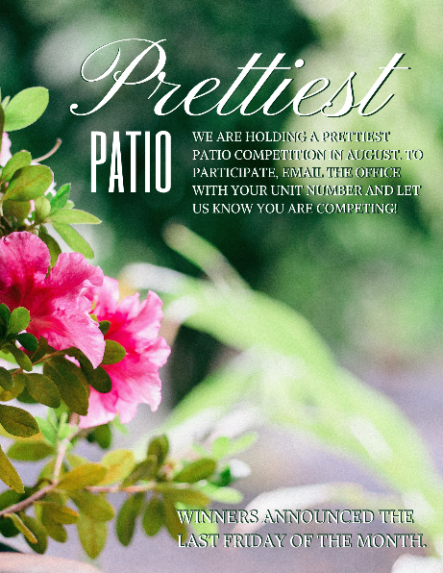
PRETTIESt PATIO CONTEST
Have fun with it. When judging patios maybe wear your finest lawn and garden attire – think hats, heels, gloves, the works. You could invite residents to follow you for the patio tour. Residents competing could have the opportunity if they like to give a brief chat regarding their efforts. The resident that wins could not only win a gift card but maybe a pretty wreath to hang with a ribbon nicely placed on it indicating they are your most distinguished prettiest patio winner. It’s a great opportunity to provide a little whimsy and fun for your community as well as spread motivation to create beauty.

BEFORE THE EVENT:
- Post social graphics and hand out flyers in advance of your event so residents can plan on it.
- Purchase Prizes for the Winner(s).

THE DAY OF THE EVENT:
- Post the social media square to remind your residents. Gather your judges and spectators and make a big to-do about how lovely everyone’s patio looks. Have a fair grading scale printed out for judges so that it will make it easy to pick a winner.
- Once a winner has been declared, make sure to post the results and maybe even a full gallery on Social Media.

outreach
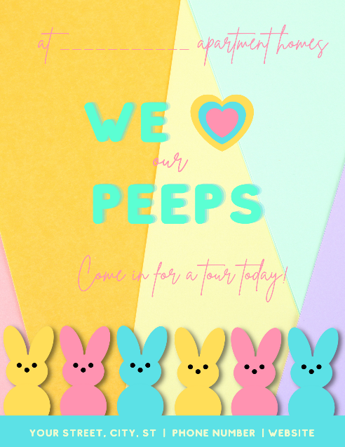
You will find outreach flyers in our gallery this month. If you are passing them out to local businesses and including Peeps! If you are visiting a larger office with a breakroom, a box of spring donuts or cookies would be a great addition to the flyer.
Get Involved with your Local Library – Are there any events/programs you can volunteer at or contribute too?
Bookstores & Café’s -Bookmarks make great takeaways here
Pet Stores/ Vet’s / Pet Grooming – Bring a jar of treats with you

Please take the time today to review your
Royal American Microsite:
https://www.royalamerican.com/communities
and your Social Media Pages for accuracy
(FB, Google Listing, etc.)

01 – April Fool’s Day / International Fun at Work Day: Post something silly or fun to make your residents smiled today.
02 – World Autism Day - https://www.autismspeaks.org/world-autism-awareness-day
03 – Find a Rainbow Day - Find a Rainbow Day – Hide rainbows around the property. Residents that find them can bring them to the office and get a prize (a bag of skittles!) Only 1 prize per resident.
06 – National Walking Day - Make a map or list of awesome businesses within walking distance to your community. This will be helpful for current residents and future ones!
07 – World Health Day- Host a local professional that can teach your community a healthy skill (Yoga, Cook a healthy meal, A stretching routine, a deep breathing exercise,etc.)
07 – World Burrito Day – Who has the best burrito in town? Tag a local business in the comments.
08 – National Zoo Lover’s Day - Post a link to the zoo realtime cameras to celebrate! Don’t have a local zoo? No Worries! Check out the links below.
https://nationalzoo.si.edu/webcams
https://zoo.sandiegozoo.org/live-cameras
09 – National Unicorn Day – Unicorn Activities Galore: https://parenting.firstcry.com/articles/easy-unicorn-crafts-and-activities-for-kids/
10 – National Hug Your Dog Day – Just a reminder to give extra snuggles today.
11 – National Pet Day – Host a FB pet contest – Give awards for (cutest/fluffiest/coolest, etc.)
12 – National Scrabble Day – Invite residents to take a minute to check out and play scrabble on your patio today
13 – National Gardening Day – Post a few Patio Gardening Ideas today: https://www.marthastewart.com/337398/small-space-garden-ideas?slide=e1e1c4c9-33ae-46b3-bb15-6862c82347c1#e1e1c4c9-33ae-46b3-bb15-6862c82347c1
13 – National Pecan Day
14 – Jackie Robinson Day – See Gallery for Quote
15 – World Art Day - Host an art contest and post entries on your FB wall like a virtual gallery.
16 – National Librarian Day – Post a link to your local Library and their events today!
17 – Easter
18 – National Animal Cracker Day – Offer Animal Crackers in the office. You could offer them with a tag that says “We are wild about our residents!”
20 – National Banana Day – It’s a great day for baking! https://www.simplyrecipes.com/recipes/banana_bread/
21 – National Tea Day – Host a Spring Tea Party
22 – Earth Day – Ask for residents to tell you how they are celebrating Earth Day on FB. If they comment on your post then they are entered into a drawing.
22 – Jellybean Day – Invite children on property today to “plant” jellybeans in a planter at the office. Have them come check tomorrow to see what happens. Replace the jellybeans with dum dums in the morning before visitors come.
23 – World Book Day – Host a Book Exchange in the office.
“WE ARE HOSTING A BOOK SWAP IN THE OFFICE. BRING A BOOK TO SWAP ANYTIME TODAY!”
23 – National Picnic Day – Invite residents to picnic out in your greenspace for lunch today. Have water out as well as any additions you want to provide – fruit, chips, treats, etc.
26 – Get Organized Day - Post Tips or Ask residents their best organizational tips specific to your apartments
26 – National Pretzel Day - Put bags of pretzels on resident’s doors today with tag “ We do knot know what we would do without you”
27 – Administrative Professionals Day - Make sure to do something nice for your Admin’s today.
28 – National Superhero Day
29 – National Arbor Day – Here are a few examples of patio perfect tree options to share with your residents! https://www.bobvila.com/slideshow/these-trees-and-shrubs-thrive-in-containers-197847 -
29 – International Dance Day - Post a dance trend to learn, make up a dance and share with your community, call out your residents and challenge them to a virtual dance battle.
30 – National Oatmeal Cookie Day – Have Oatmeal crème pies in the office today for visitors

