NOVEMBER 2022 MARKETING PLAN

November is the month where everything is about fall. This month think cinnamon spice, chai, and all things cozy! Check out a few ideas below on how you can carry out this theme all month long.

getting started
- Review ideas and pick the ones you would like to do!
- Purchase the supplies needed for your events.
- Spread the word via graphics included for each event. You can find them in the galleries on each month’s page on the website.
- During each event *with permission* take photos and make sure to post to your social media to encourage future participation and remind attending residents of all the fun they had!
Keep in mind that the materials below are customizable to your property as far as time, date, and location. Simply reach out to the marketing department and specify which piece of collateral you want adjusted and send us your changes.

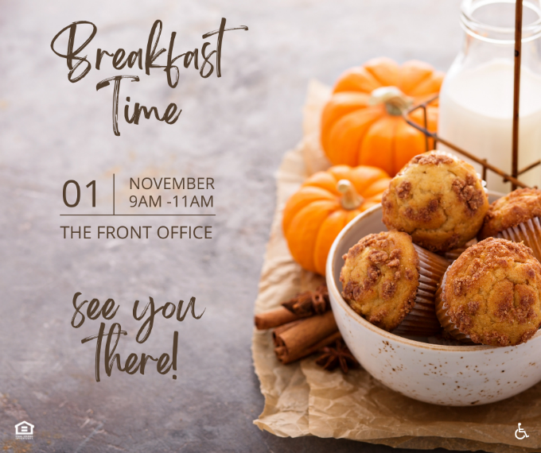
FAll Forward rent breakfast

Have fall themed teas/drinks in the office. They also sell fall flavored creamers.

Check out your local donut/bagel shop for a quick pick-up of fall themed items! Don’t forget little plates, cups, and napkins for the event.
Invite your residents via flyer, social media, textbox with the graphics included.
On the day of your event, send out a reminder via textbox and social media.

Fall Food Drive
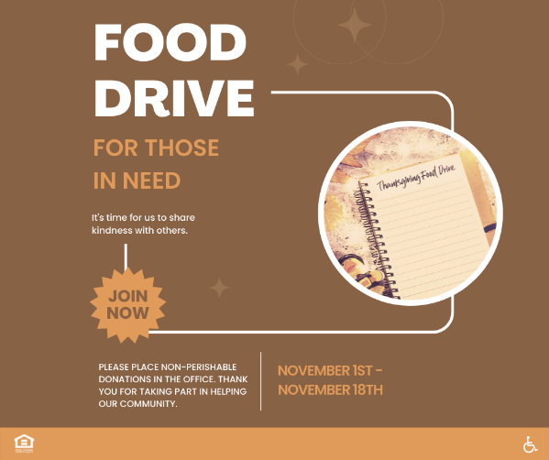
The first thing to do is to get the word out! Set up a large collection area in your community office and make sure to have signage. Coordinate where you will be donating supplies collected.
If participation is something you struggle with, maybe there is an incentive like a raffle to be entered into if you donate.
Lastly, at the end of your collection time, distribute the supplies to whom you were collecting for. Make sure to take a photo of what was collected and post on your social media. Be mindful of posting any pictures including recipients as they may not want to be featured.

Guess how many
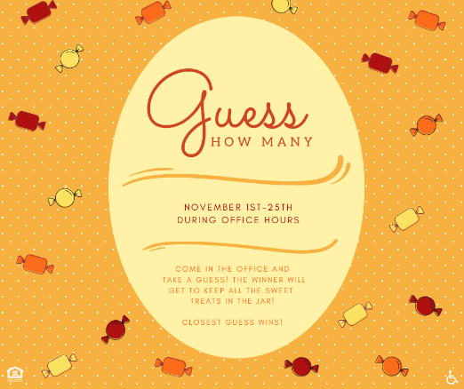
This is an easy one to facilitate.
Find a large jar you would like to fill. Fill it to the top with the candy of your choice! We recommend something that lends itself to the fall season.

Have a box available nearby to collect guesses. Make sure to also set out little sheets of paper for residents to write their guess on. Make sure your guess papers ask for name & unit # so you can ensure the prize is awarded to the right person.

Post on social and print flyer letting residents know they can come guess how many are in the jar.

When the event is over, count how many candies were in the jar and then review all the guesses. Award your winner with the candy and post the winner (with their permission) on social after you deliver the prize!

boardgame night/puzzle night
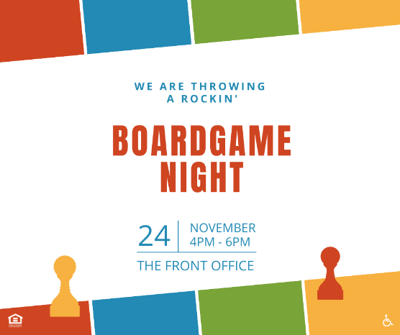
Invite residents of all ages to come by the office and enjoy a low key boardgame or puzzle night. Post the graphic/flyer that corresponds with whichever event suits your needs.
This one should take minimal effort. Simply provide either games or puzzles for your residents to partake in.
If you like, you can provide drinks and light refreshments as well.

fall flag football event
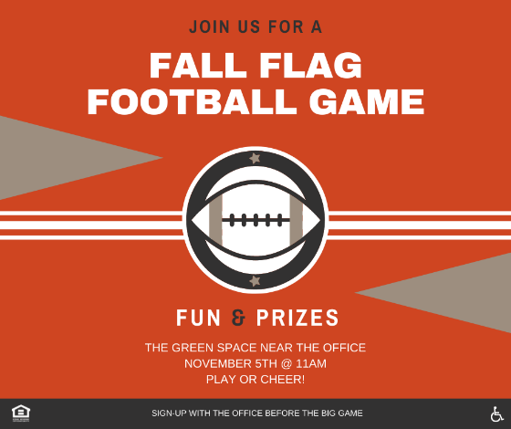
Send out a notice in advance of your plan to host a fall flag football event. Once you get enough people signed up, divide teams up.
Decide on a prize for the winning team and make sure to have it on hand.
Try to get ahold of a score board of sorts – Maybe you have a chalkboard or easel someone can keep score on. Or purchase something like this: https://www.amazon.com/HSZJsto-Portable-Scoreboard-Flipper-Sports/dp/B07T1RVN61/ref=sr_1_16?crid=3Q4UQI86SVHEU&keywords=tabletop+scoreboard&qid=1661268041&sprefix=tabletop+score%2Caps%2C90&sr=8-16

Make sure to order flags for the game: https://www.amazon.com/SKLZ-10-Man-Football-Deluxe-Cones/dp/B0019GM3HC/ref=sr_1_3?crid=1NTRFJ1S81MS8&keywords=flags%2Bfor%2Bflag%2Bfootball&qid=1661267750&sprefix=flags%2Bfor%2Bflag%2Caps%2C97&sr=8-3&th=1

Make sure to also get ahold of a few footballs.
Encourage residents to come out and be the cheering section. They can bring their own fold out chairs for seating. Provide waters, drinks, and light snacks like individually packed bags of snacks for your attendees.

THE DAY OF THE EVENT:
- Send out a reminder, set up your event, and enjoy! Take a lot of pictures (with permission) to capture the fun of this event. Share on your social media page.

outreach
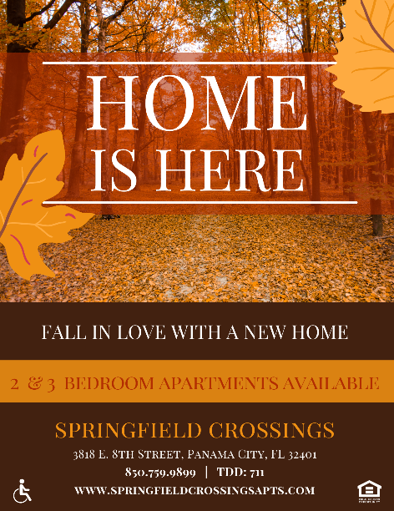
You will find outreach flyers in our gallery this month. I. We suggest If you are visiting a larger office with a breakroom, a box of fall flavored treats like pumpkin scones or cinnamon crunch muffins.
November Marketing Thoughts:
- Think all things sports – Namely Football. Are their local games going on? Any sports shops? Any tailgate events you can sponsor?
- November is a very community centric time of you. It’s the time of year to surround yourself with those you are grateful for and give back to those with less. Are there any events going on your team can be a part of or help out with?
- Don’t forget about your local doctor’s offices in light of no-shave November! It’s a month that brings to the forefront men’s health issues. With routine check-ups being spotlighted, there may be more traffic than usual.

