DECEMBER 2022 MARKETING PLAN

December is the month full of seasonal cheer. This month think peppermint, cocoa, and all things toasty! Check out a few ideas below on how you can carry out this theme all month long.

getting started
- Review ideas and pick the ones you would like to do!
- Purchase the supplies needed for your events.
- Spread the word via graphics included for each event. You can find them in the galleries on each month’s page on the website.
- During each event *with permission* take photos and make sure to post to your social media to encourage future participation and remind attending residents of all the fun they had!
Keep in mind that the materials below are customizable to your property as far as time, date, and location. Simply reach out to the marketing department and specify which piece of collateral you want adjusted and send us your changes.

Peppermint & mocha rent breakfast

Espresso may not be an option but we can do a makeshift “mocha” with coffee and chocolate additions like a chocolate drink syrup. They also sell mocha flavored creamers. Peppermint is also a popular flavor this year.

Visit your local bakery or grocery store to pick up muffins and you are all set! Don’t forget little plates, cups, and napkins for the event.
Invite your residents via flyer, social media, textbox with the graphics included.
On the day of your event, send out a reminder via textbox and social media.

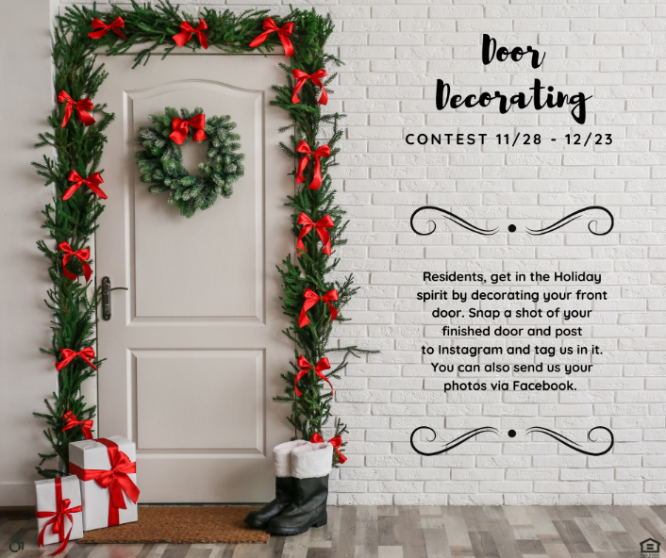
DOOR/WREATH DECORATING CONTEST
Have fun with it. When judging doors/wreaths maybe wear your finest winter attire – think hats, heels, gloves, the works. You could invite residents to follow you for the judging tour. Residents competing could have the opportunity if they like to give a brief chat regarding their efforts. The resident that wins could not only win a gift card but maybe a pretty ribbon to hang indicating they are your most distinguished winner. It’s a great opportunity to provide a little whimsy and fun for your community as well as spread motivation to create beauty.

BEFORE THE EVENT:
• Post social graphics and hand out flyers in advance of your event so residents can plan on it.
• Purchase Prizes for the Winner(s).

THE DAY OF THE EVENT:
• Post the social media square to remind your residents. Gather your judges and spectators and make a big to-do about how lovely everyone’s doors/wreaths look. Have a fair grading scale printed out for judges so that it will make it easy to pick a winner.
• Once a winner has been declared, make sure to post the results and maybe even a full gallery on Social Media.
HOT COCOA BAR
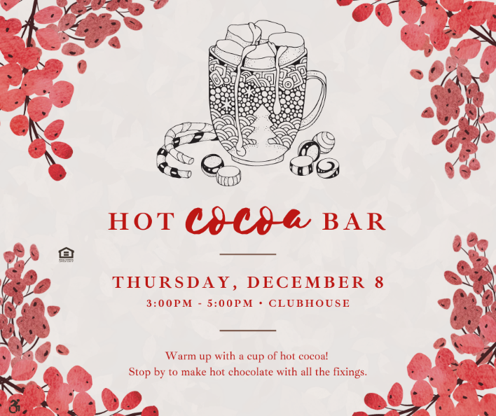
Host a Hot Cocoa Bar for your Residents!
- The easiest way to keep hot cocoa warm from our experience is in a carafe’ if your community has one or in a crock pot (on keep warm) with a ladle for serving.
- A few ideas for toppings include: mini marshmallows, different chocolate chips, peppermint chips, whipped cream, etc.
- Make sure to have little bowls for your toppings along with serving spoons, cups specific for hot items, spoons, and napkins.

Make sure to notify residents via email/social/textbox.

HOLIDAY TOY DRIVE
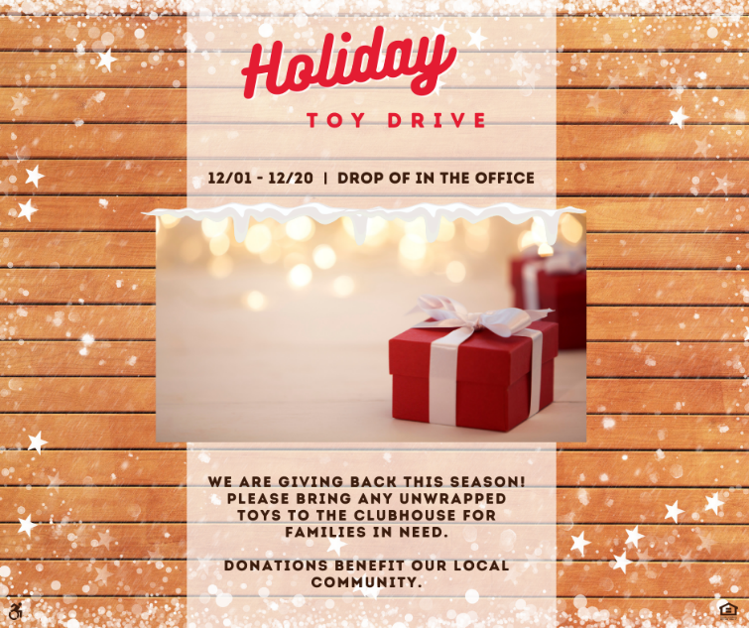
The first thing to do is to get the word out! Set up a large collection area in your community office and make sure to have signage. Think about who all you want to drop off supplies – is this just for residents, the community, etc.
Next, think about who will be receiving these supplies. Are there organizations for those in need in your area? Are there local clubs that assist with after school needs like boys and girls clubs collecting? Are some of your residents in need of assistance and do you have a way to gather that information sensitively?
If participation is something you struggle with, maybe there is an incentive like a raffle to be entered into if you donate.
Lastly, at the end of your collection time, distribute the supplies to whom you were collecting for. Make sure to take a photo of what was collected and post on your social media. Be mindful of posting any pictures including recipients as they may not want to be featured.

MILK & COOKIES EVENT
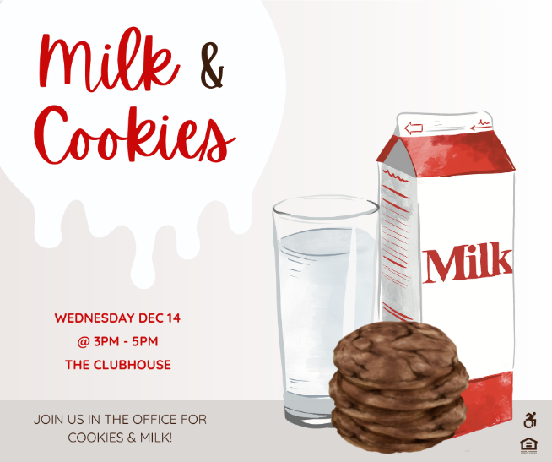
Who doesn’t love cookies and milk? Go by your local grocery or bakery and pick up an assortment of cookies. Make sure to grab a variety of milks including an option for those who are lactose intolerant.
Make sure to send out a notice in advance by a few days to make sure residents know this is coming up.

THE DAY OF THE EVENT:
- Send out a reminder, set up your event, and enjoy!

sPARKLE BAR

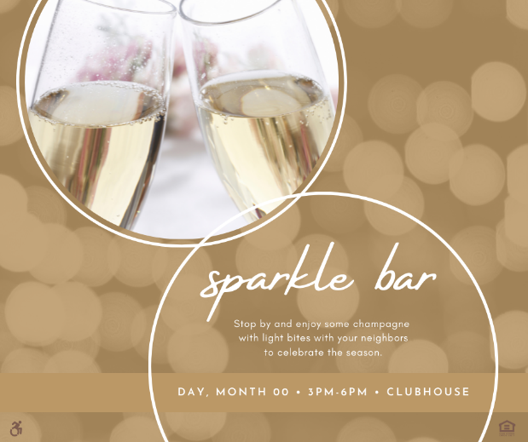
Host a sparkled bar for your residents to celebrate the close of this year and what the new year has to bring. Get with your regional on your community’s policy on champagne/alcohol. There are plenty of non-alcoholic options that sparkle!

A few ideas:
- Non-Alcoholic Sparkling Wine
- Ciders
- Sparkling Grape Juice
- Sparkling Sodas
ADDITIONS
- Fruit (frozen or fresh)
- Fresh Herbs like mint
- Juices

Have a few snacks to eat to go along with your sparkle bar – maybe crackers, cheese, fruits, etc. Make sure to have mini plates, napkins, forks, serving utensils for drink additions, and plastic champagne glasses.

- Post photos on social media (with resident’s permission) to show others and encourage future participation.

WINTER GET TOGETHER
Host a get together for your residents. Plan something that resonates with what your residents enjoy. Maybe this event revolves around food and beverages. Maybe your residents like a fun winter themed photo booth. Maybe your residents enjoy games and prizes. Center this around what works for your residents.

• Post photos on social media (with resident’s permission) to show others and encourage future participation.

outreach
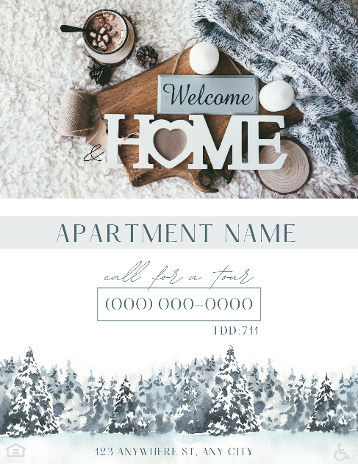
You will find outreach flyers in our gallery this month. We suggest If you are visiting a larger office with a breakroom, a box of holiday cookies would be a nice addition.
December Marketing Thoughts:
- Think all things Holidays! December is full of many types of celebrations.
- December is also a time to focus on giving back. Make your mark in the community by getting involved as a staff.

